**Daily Companion App: Innovative Concept**

This document describes the core innovative idea behind the Daily Companion app, its intended audience, how users will interact with it, the anticipated benefits for users, and the roles required for its development.

**Innovative Idea: The Proactive AI Companion**

The central innovation of the Daily Companion app lies in its integration of a deeply personalized and *proactive* AI. Unlike standard tracking apps or simple chatbots, this AI doesn't just respond to queries; it actively analyzes the user's tracked data (habits, activities, mood, etc.) and planning entries to offer intelligent, context-aware insights, suggestions, and nudges.

For example, if the AI notices a dip in productivity correlating with a lack of sleep based on tracked data, it might proactively suggest adjusting the user's evening routine or planning fewer demanding tasks for the next day. If a user is consistently missing a planned habit, the AI could help identify potential blockers or suggest alternative approaches. This moves the app from a passive data repository to an active partner in the user's self-improvement journey.

**Target Users**

The primary target users are individuals who are motivated to improve their personal well-being, productivity, or habits but may struggle with consistency, identifying patterns, or knowing the best steps to take. This includes:

* Individuals seeking to build or break habits.
* People looking to optimize their daily routines for better energy or focus.
* Users interested in understanding the correlation between different aspects of their lifestyle (e.g., sleep, diet, exercise, work).
* Anyone who appreciates personalized guidance and data-driven insights.

**Interaction Method**

User interaction is primarily through a intuitive mobile application interface. This includes:

* **Standard UI:** Using buttons, forms, calendars, and data input fields to log activities, create plans, and configure settings.
* **Visual Dashboards:** Interacting with dynamic charts, graphs, and summaries to visualize tracked progress and insights.
* **Conversational AI:** Engaging with the AI through a chat interface, asking questions, receiving suggestions, and getting explanations for insights.
* **Notifications:** Receiving proactive nudges, reminders, and insights from the AI via push notifications.

**Expected Outcome**

The expected outcomes for users include:

* **Increased Self-Awareness:** Gaining a deeper understanding of their habits, patterns, and what influences their well-being and productivity.
* **Improved Habits and Routines:** Successfully building positive habits and optimizing their daily schedule based on personalized data and AI guidance.
* **Enhanced Productivity:** Better planning and proactive adjustments lead to more focused and effective days.
* **Progress Towards Goals:** Making consistent progress towards personal goals related to health, fitness, learning, or other areas.
* **Feeling Supported:** Having a digital companion that provides intelligent, non-judgmental support and motivation.

**Team Role**

**Designer** (Sketches, Low-Fidelity Wireframes and Figma) – Saw Ke Blute (202300154)

**Researcher** – Mario Rezk Saadalla Rezk (202300302)

**Documenter (Presentation, Google Form & Testing users)** – Saw Joshua (202300311)

**Sketches Goals**

The Goals of sketches are to:

Brainstorm and investigate different layout and interaction possibilities in a hurry.

Visualize user interface organization and key screens without spending time on specifics.

Facilitate feedback from users, colleagues, or instructors early on.

Facilitate decision-making by being able to compare multiple design ideas.

Identify usability issues or functionality holes early.

**Figma Link**

[**https://www.figma.com/design/4Mgn40wlFT5yRfKBQDuJiI/DailyCompanion?node-id=0-1&t=bYGzusMEVN3SavL3-1**](https://www.figma.com/design/4Mgn40wlFT5yRfKBQDuJiI/DailyCompanion?node-id=0-1&t=bYGzusMEVN3SavL3-1)

1. What is the app for?

The "Daily Companion" app is designed to be a personal assistant and tracking tool. It helps users with planning their activities, offers interaction through an AI chat feature, and allows for tracking various aspects of their daily lives, potentially related to habits, health, or activities, providing historical data and insights.

1. **Features**

**Authentication System (Login)**

1. **Purpose: This crucial set of features ensures the security of user data and provides controlled access to the application. It handles user registration, login, and the process for recovering or changing passwords.**
2. **Buttons/Elements:**
   1. **Login Button (Black/Grey): The primary action button to proceed with logging into an existing account.**
   2. **Continue with Google Button (Black/Grey with Google logo): Offers a convenient alternative login method using a user’s existing Google credentials, simplifying the sign-in process.**
   3. **Forgot Password Link: The password recovery workflow for users who cannot remember their password.**
   4. **Reset Password Button (Black/Blue): Sends a password reset link or code to the user’s registered email address.**
   5. **Verify Code Button (Black/Blue): Confirms the validity of the verification code sent to the user’s email during the password reset process.**
   6. **Resend email Link: Allows users to request a new verification email if the initial one was not received or expired.**
   7. **Confirm Button (Black/Blue): Finalizes the password reset process after successful verification and typically leads to setting a new password.**
   8. **Update Password Button (Black/Blue): Saves the user’s newly chosen password.**
   9. **Back Arrow Button: A standard UI element allowing users to navigate back to the previous screen in a sequence, particularly useful in multi-step processes like password reset.**
3. Step-by-Step Process: Password Reset
4. **Initiate Reset:** The user clicks on the "Forgot Password?" link (implied, as the "Forgot password" screen is shown), typically found on the login screen.
5. **Enter Email:** On the "Forgot password" screen, the user enters the email address associated with their account into the provided input field.
6. **Request Reset:** The user clicks the "Reset Password" button to request the verification process.
7. **Check Email:** The application sends a verification code to the user's email address. The user is automatically or manually directed to the "Check your email" screen.
8. **Enter Verification Code:** On the "Check your email" screen, the user retrieves the 5-digit code from their email and enters it into the provided input fields.
9. **Verify Code:** The user clicks the "Verify Code" button to submit the entered code for verification by the application.
10. **Password Reset Confirmation:** Upon successful verification of the code, the user sees a "Password reset" confirmation screen, indicating that the reset process can proceed.
11. **Confirm Reset:** The user clicks the "Confirm" button on the confirmation screen, acknowledging the successful verification and moving to the next step.
12. **Set New Password:** The user is directed to the "Set a new password" screen where they are prompted to create and enter a new password and then re-enter it to confirm accuracy.
13. **A screenshot of a phone

    AI-generated content may be incorrect.Update Password:** The user clicks the "Update Password" button to save the new password and complete the password reset process.

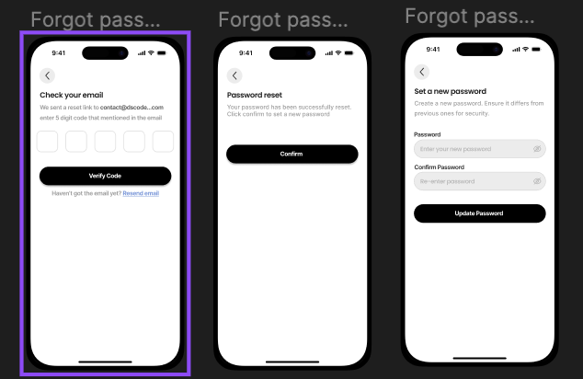

1. **Home**

The **Home** page, as depicted in the provided design, functions as the central dashboard and initial view for the user upon opening the application after logging in. This screen prominently features a date selector at the top, allowing users to easily navigate between different days to view their progress and plans. Below the date selector, the core of the Home page displays a list of various activities or habits that the user is tracking, including "Walking," "Meditation," "Meals," "Sleeping," "Work," and "Study," each represented by a clear icon and label. Crucially, next to each activity, the screen shows a progress indicator, displaying the user's current achievement towards a predefined goal for that specific day (e.g., "0/10000 steps" for Walking, "0 / 30min" for Meditation, "0 / 8h" for Sleeping), providing an immediate visual summary of their daily progress across key areas.

1. **Planning/Daily Tracking Feature:**

* **Purpose:** This feature, as shown in the daily views ("Today," "Monday," etc.), is designed to help users organize, schedule, and track their daily activities, habits, or tasks. It provides a clear overview of what needs to be done on a specific day and allows users to mark completion. This feature works in conjunction with the broader "Planning" capabilities (Weekly, Monthly, Yearly) to manage time and goals effectively.
* **Buttons/Elements:**
  + **Day Navigation (Today, Monday, Tuesday, etc.):** These likely function as buttons or tabs that allow the user to switch between different days of the week to view or manage their schedule and tracking for that specific day. "Today" would show the current day's activities.
  + **Activity/Habit List Items:** Each item in the list (e.g., "Walking," "Meditation," "Work," "Study," "Sleeping") represents a specific activity or habit the user is tracking or has scheduled for that day.
  + **Completion/Status Indicators (Circular Icons):** The small circular icons next to each activity likely indicate the status of that activity for the day. They could show if an activity is planned, in progress, completed, or perhaps skipped. The checkmark within a circle suggests a completed status.
  + **Time/Duration Display:** The text next to the activities (e.g., "9:00 AM," "30 Min," "8:00 PM," "8 Hrs") shows the scheduled time or the planned/logged duration for that activity.

1. **Chat Interface ("Ask me anything"):**

* **Purpose:** To provide users with a conversational way to interact with the application. This feature likely utilizes an AI or chatbot to understand natural language queries and provide relevant information, assistance, or perform actions related to the user's daily life. **Based on the application's other features (Planning, tracking daily activities which often relate to health), the chat with the AI appears to be particularly focused on assisting users with health-related queries and making daily plans.** It could potentially integrate with other features like Planning and Tracking to offer personalized insights or help manage schedules and goals through conversation.
* **Buttons/Elements:**
  + **Text Input Field:** Labeled "Ask me anything about your daily life," this is the primary area for user input. It suggests the chatbot is designed to handle questions and requests related to personal routines, activities, or information the user might need throughout their day.
  + **Send Button (Paper Airplane Icon):** Submits the user's typed message to the chatbot for processing.
  + **"Hello" Button:** Could serve as a quick way to initiate a conversation, a pre-defined prompt, or perhaps even trigger a brief onboarding message from the chatbot.
  + **"Typing..." Indicator:** Provides visual feedback to the user that the chatbot is processing their request and generating a response

1. **Settings Feature:**

* **Purpose:** The Settings feature allows users to manage their account, customize their application experience, and access information about the app. It provides control over personal details, notifications, and other preferences.
* **Buttons/Elements (within Settings screens):**
  + **Main Settings Menu (Setting1):**
    - **"Premium Membership" Button:** Likely provides information about or allows the user to purchase/manage a premium subscription.
    - **"Account" Section Header:** Groups account-related settings.
    - **"Profile" Button:** Navigates to the Profile settings screen.
    - **"Password" Button:** Navigates to password management settings (potentially leading to the "Confirm Your Password" flow).
    - **"Notifications" Button:** Navigates to the Notification settings screen.
    - **"More" Section Header:** Groups additional settings or information.
    - **"Rate & Review" Button:** Navigates to the Rate & Review screen.
    - **"Log out" Button:** Allows the user to sign out of their account.
  + **Profile Settings (Setting2):**
    - **Back Arrow Button:** Returns to the main Settings menu.
    - **Input Fields:** Fields for entering or editing personal information such as First Name, Last Name, Username, Gender, Date of Birth, Email Address, Phone Number.
    - **"Confirm" Button:** Saves the changes made to the profile information.
  + **Rate & Review (Setting3):**
    - **Back Arrow Button:** Returns to the main Settings menu.
    - **Rating Display (Stars):** Shows the user's current rating or allows them to provide a rating.
    - **Review Section:** Displays existing reviews or provides an area for the user to write a review.
    - **"Verified Purchase" Label:** May indicate that the review is from a user who has made a purchase within the app.
  + **Confirm Your Password (Setting4):**
    - **Back Arrow Button:** Returns to the previous screen (likely Password settings or a flow requiring password confirmation).
    - **Instructional Text:** "Please enter your password to get access."
    - **Password Input Field:** For the user to enter their current password.
    - **"Enter Password" Button:** Submits the entered password for verification.
  + **Notification Settings (Setting5):**
    - **Back Arrow Button:** Returns to the main Settings menu.
    - **"Common" Section Header:** Groups general notification settings.
    - **Toggle Switches:** Allow the user to enable or disable different types of notifications (e.g., General Notification, Sound, Vibrate).
    - **"System & services update" Section Header:** Groups notifications related to app updates and services.
    - **Toggle Switches:** Control notifications for App updates, Bill Reminder, Promotion, Discount Available, Payment Request, Others.

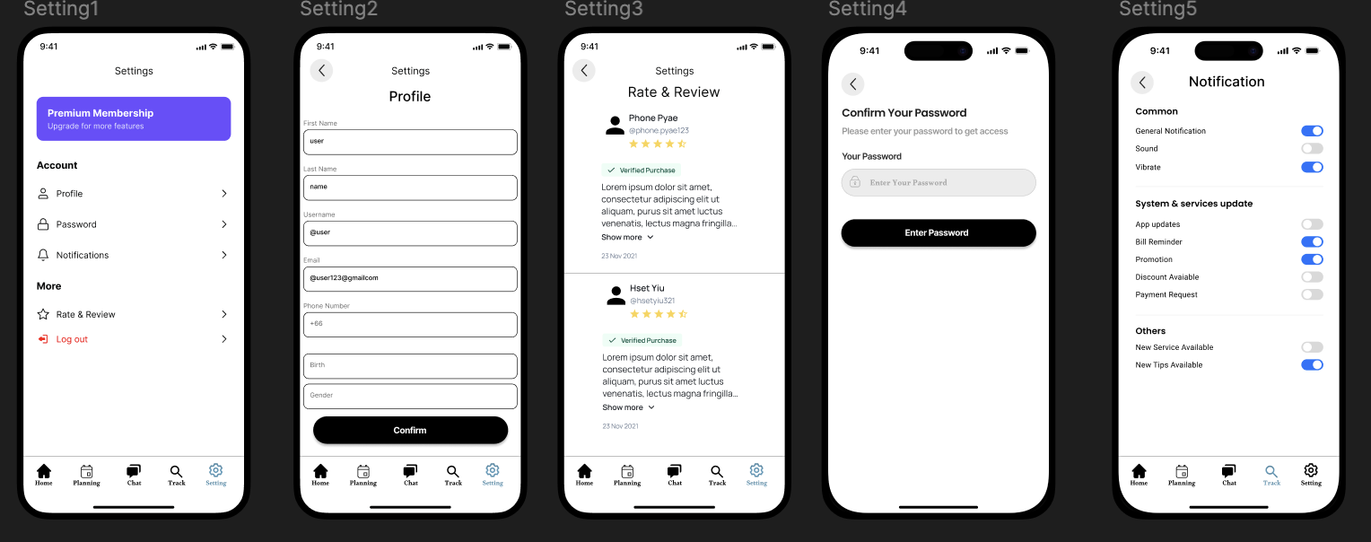

DailyComprasion App Survey Form Link

<https://docs.google.com/forms/d/e/1FAIpQLSdMaCw-3qCOiZwbM-4NFxyLvUTlSmc-g3UkPkOeXP_B_VwgcA/viewform?usp=header>

How many people responded to the survey?

Eleven people responded to the survey.

**Here the Reponses:**



